< Consideration-Price (Rs.)

*0* " *0*

**11,50,000 O :a C O**

**8 O O o**

(Eleven Lakh Fifty Thousand onl 1 • • •

0 0

First Party Second Party

Stamp D4ty:P; .d. *y* .

KAKOLLU VENKATESWARLU Af D VEMURl SUBASH>N U

0 0

RASHMl RANJAN SWAIN • *:*

0

RASHMl RANJAN SWAIN

0

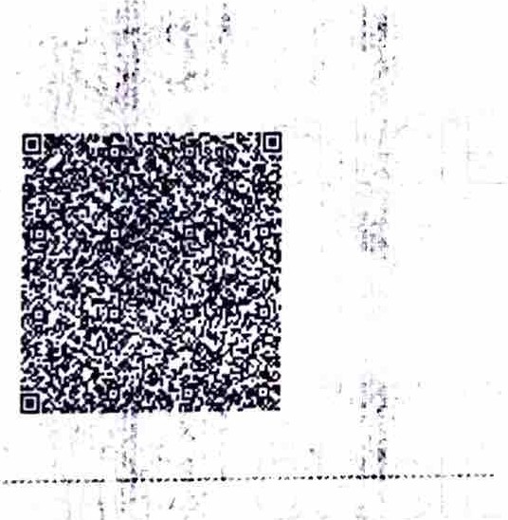Stamp Duty Arriount(Rs.)

...._,•--····-·····

- .c,'

57,550

(Fifty Seven Thousand Five Hundred And Fifty only)

Pl ase Writ or t pt below this hllC

0 0 0

* 0

.i



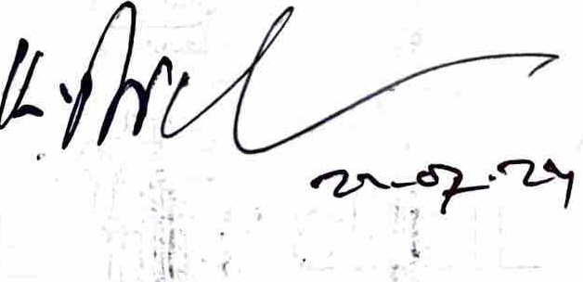lq;J. 0-.'4-CJ

\-<'.6-'u,Lt..V J}

"--

*:* \ *l*'·



,.

_; \. " - -

*:it* ..> ' •

S:atutory Alert

*\fr h_* ;'.

- r-vt...

"'-; *.Z.o.\\'OJ)* J ') *t*'

IE 0011086972

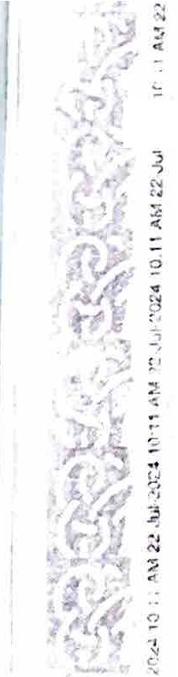.. • 1 The dt1thtrnticny *of* thts Sta *n,:;*\'.: 1ca e !>hould *be:* ve*,*-*.*,*c.Un\·.vr:,-* !' 1c lt'i,:1m 1*14* 11 , rJr L1)1ng ".!· •l I .,,, , ·4c., • ...ir,,r.,: ' -.1. rlokfri(1

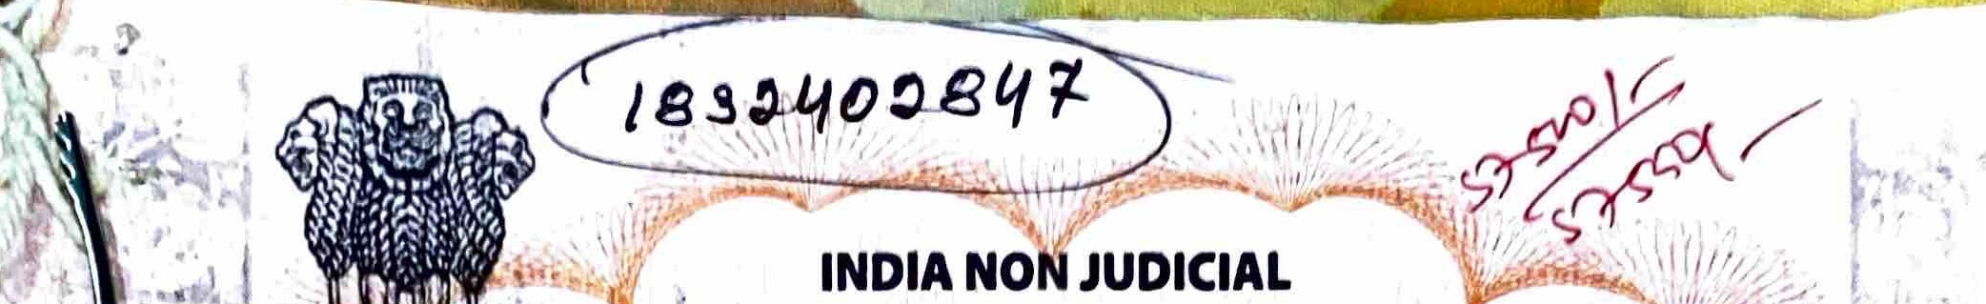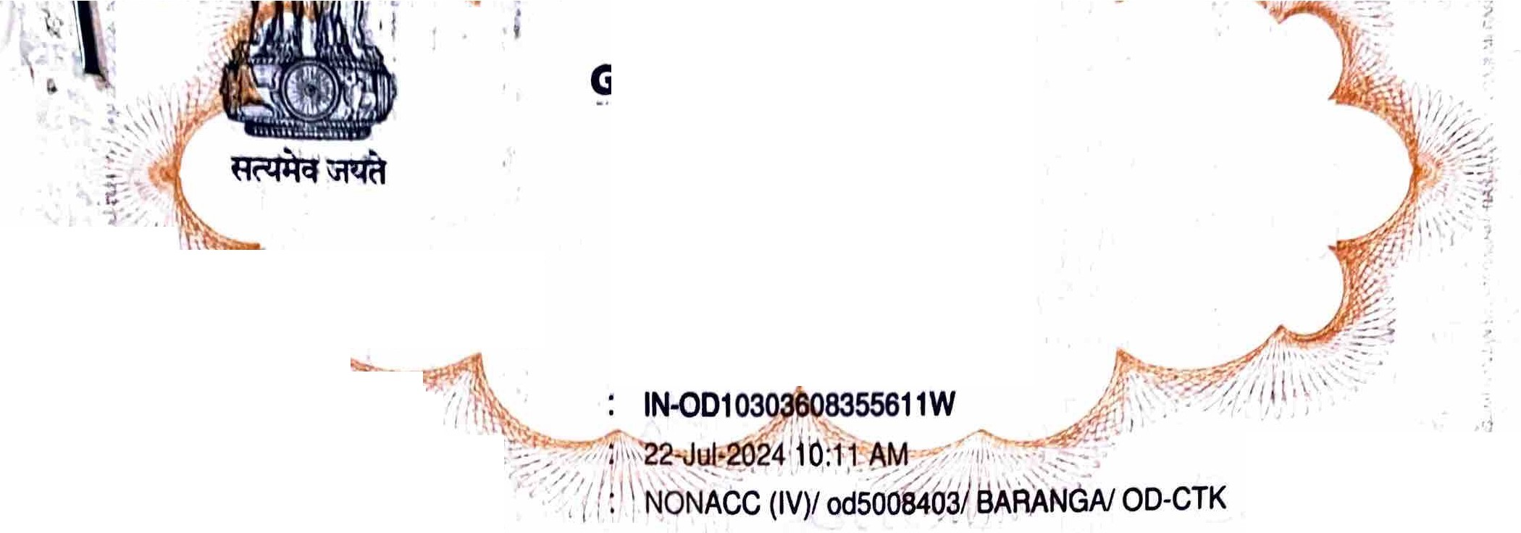

;

'

**Government of Odlsha**

,.

**•-Stamp**

'1

,,

**Certificate**I'\\' ''c-,

- •

"

'j

I

t

' • I

.

..,,

.,

Certificate ls edDate Account Reference

Unique Doc. Reference

• • •

0 0

0 0

;;_

* I

SUBIN-ODOD500840314506171298947W

RASHMI RANJAN SWAIN

0 •

Purchasecf.bY.' •·-?

'

0

0

0

Description dfb6¢u er\t I >I.' *:*

0 0

G O 00 O

I

•

*I*

Article IA-23(1) Sale Deed·

•••

0 0

j'

**Property DeSGfip ion**

0

MOUZA BELAGACHHIA

• •

0

< •

0

Any di3Clepanc.y ir, tho d.!t:1ils.on fh1s <:tirtlf1c:11 anrl ,1 a·h11la!1I en u,c w-:1 511t1• f.la 1L_, t..rp'"' •,., ,t r _;'uJ

1. Tt1e *onus* orcheckir.g th 1-u1!1rnacy 1s or tli!i u, ,,.1th rutrf.r:":I
2. *In* cnse of any disi:r",nncy n11Jase uf.ormt e Ca,,,petr.rt /,..:11·,r,ty

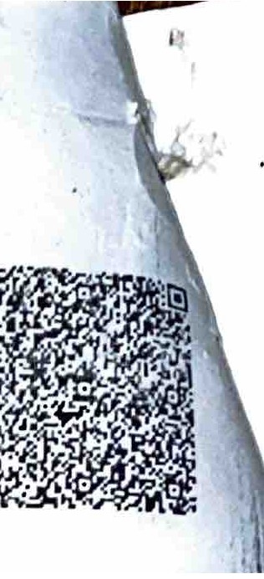10.150H. i.?51/RI':/UI'1:/111uu•,:,u,,,_ ....

7/24/24, 6:28 PM



<

*l*

. 'i-Jr.•,.,

**Endorsement of the certificate of admissibility**

Admissib under rule 25: duly stamped under the Indian stamp (Orissa Amendment act1 of 2008) Act 1899,·:

Schedu A No. ees Paid: A(1) - 23000, 1-3 - ?. User Charges - 400, Tota-l

**Datel :! 1-J0** i,- ?- *q***l/**

E,-1.J1,,,,,.1r:: \ the,r,.,ed /

,,j_,n *r•* I f

23402.,

CoII..1.. , u c.n.c . .

.R.(: CJrJ --:ga Signature of Registering office

J\sh1s K:.rnt:r t-hu an **Endorsement under section 52**

Presented for registration in the office of the Su -Registrar **Sub-Registrar BARANGA** between the hours of ·

10:00 AM and 1:30 PM on the Date **22/07/2024** hy **KAKOLLU VENKATESWARLU,** son/daughter/wife of **LATE KAKOLLU VENKAIAH** of **AT- PLOT NO- 308.D. SHREELA NAGAR, PEDAGANTYADA, VISAKHAPATANAM,**

**ti(r\A D 0012,** by caste **GENERAL,** profession **BUSINESS** and finger prints affixed..!

·l,



Signature of Presenter/ Date: 22-Jul-2024

*if*

Signature of Registering.office

* .·

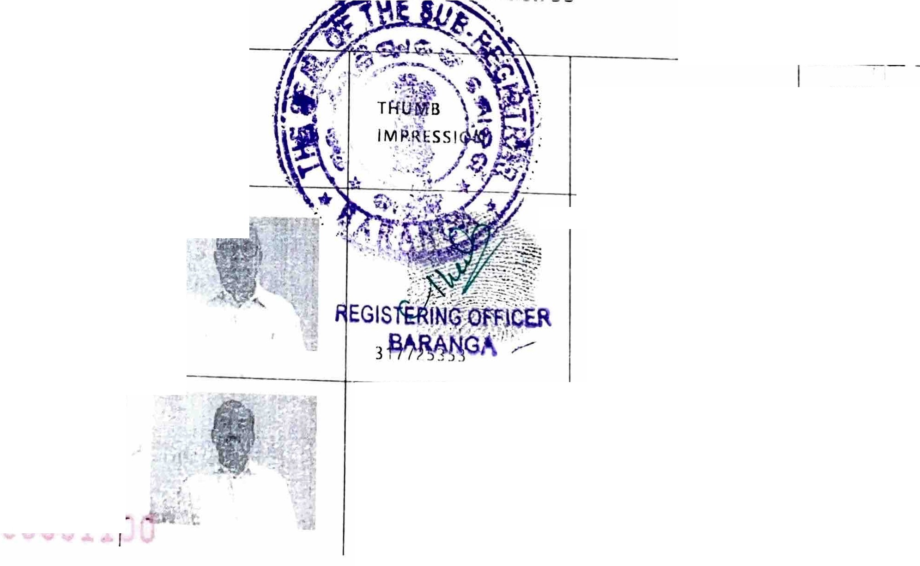

Execution is admitted by :

**SIGNATURE**

|  |  |
| --- | --- |
| **NAME** | **PHOTO** |
| **KAKOLLU V[N.KATESWARLU** |  |
| **VEMURI SUBASH NAIDU** | |

**DATE OF**

**ADMISSION OF EXECUTION**

'/J--r--------+-- --.;..." 1

..''.*J*.*-*.*:.'-,,!I.;;{* •

2?.-Jl,ll-

I

2024

.:

JUI.

**24**

I **8113 (158**

##### e1e8 ig,1813 G e115 ) 15 o o o' o **fl.' a a**8 : hGTu e kS

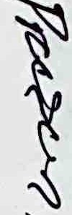I **l M '£315**: **!!lie** §

##### ' • • I Glblbo olb J

-o8'Il69 N9l££Smc1.1- **NVc!,¼tb -B-** -08

) GIRi I O O 6 *'8-G* - a8a..., 'GB8 a :1 'GBral8.[..3, I 9

01

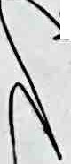

·'

-

##### : ·1139 '181381RG :Ir3 '8l l aI8 :1&139 '8' :8Ia 'Gt>

' ...., ,

- .... ,..

raI8 8'G-" l :I8B ,

##### '*>*&Lblb8 f3'08 '***t***G***:\*** I 8iae el@

\

*1*

G f3 '1B I...,

....,

##### : 131R £> 1318 518 9

I Lbo olb-S.G - a8a :tt'5§ I8 :I8Ira 'G1a8I 8 : ·1139 'G1a81 8 :Ir3

"\ -

1

f.: \

'8...,1 '01 8 :1&B9 'I :8...,Ia **53 dll86NclfVV- NVcl** I *'8-* 6 oo Jc)Lb *G*G -o8 GIRi I *G* c) o d*'8-G* -1*>*©1 9 :lt5.a.., 'GBe ig,9 8 :I8Ira, ·Ir39 'Glg,898 'GBG ig,9 8 '6

-lf3 '1'0 989I8.8.., "'t00 9 :I8B..., '*>* '8-8

- f f3'08 °8518 , Le e9 i1g, ( 6) NL££8AcISHV - NVcI

i

##### *1* I o o c) J G Go *Go'8-* 6 -o8 elRI I 6 c) ooLb'B- - 00 1

t '13 81 @ 'GMI '§'JOlb :Ir3 '1'0ha 9 1a91a :18

' o(f8 f338 e 895lS9 15915 l@ **(a) o8ib§**

_g .: 131R £> 1318 5811318 .9..

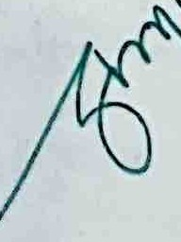*j* **1 ae** 139e-a

YDN YS

3 1:1:i0 8NIH3!Slg3if

*Q ..* 0,0h 14 "'

0 .. ,e oo *1--e* (

"'·CO I.\ (()J'

**o•M.O<t:'e** "

--- .-?"

j

'iH

I •

**1)9!J!J8f\ uonent!J\**

paH,rn,, ·ero·tt

t

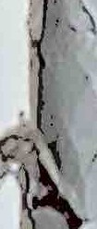

,...'

//2t.l24. 6:28 PM

22-JUL-

2024

KAKOLLU RAVI CHANDRA

2?-JUL-

2024

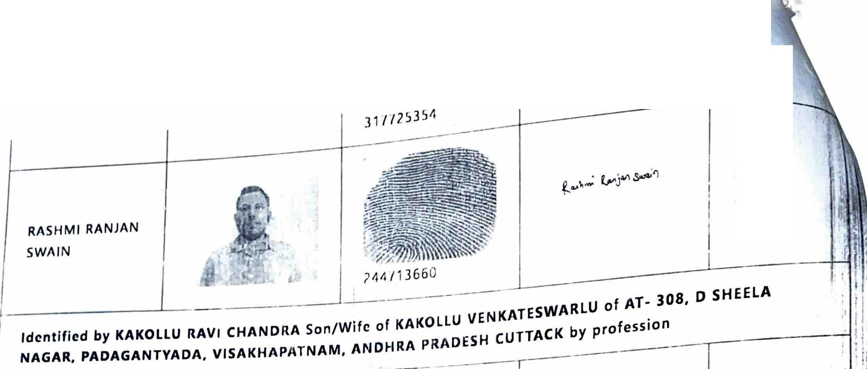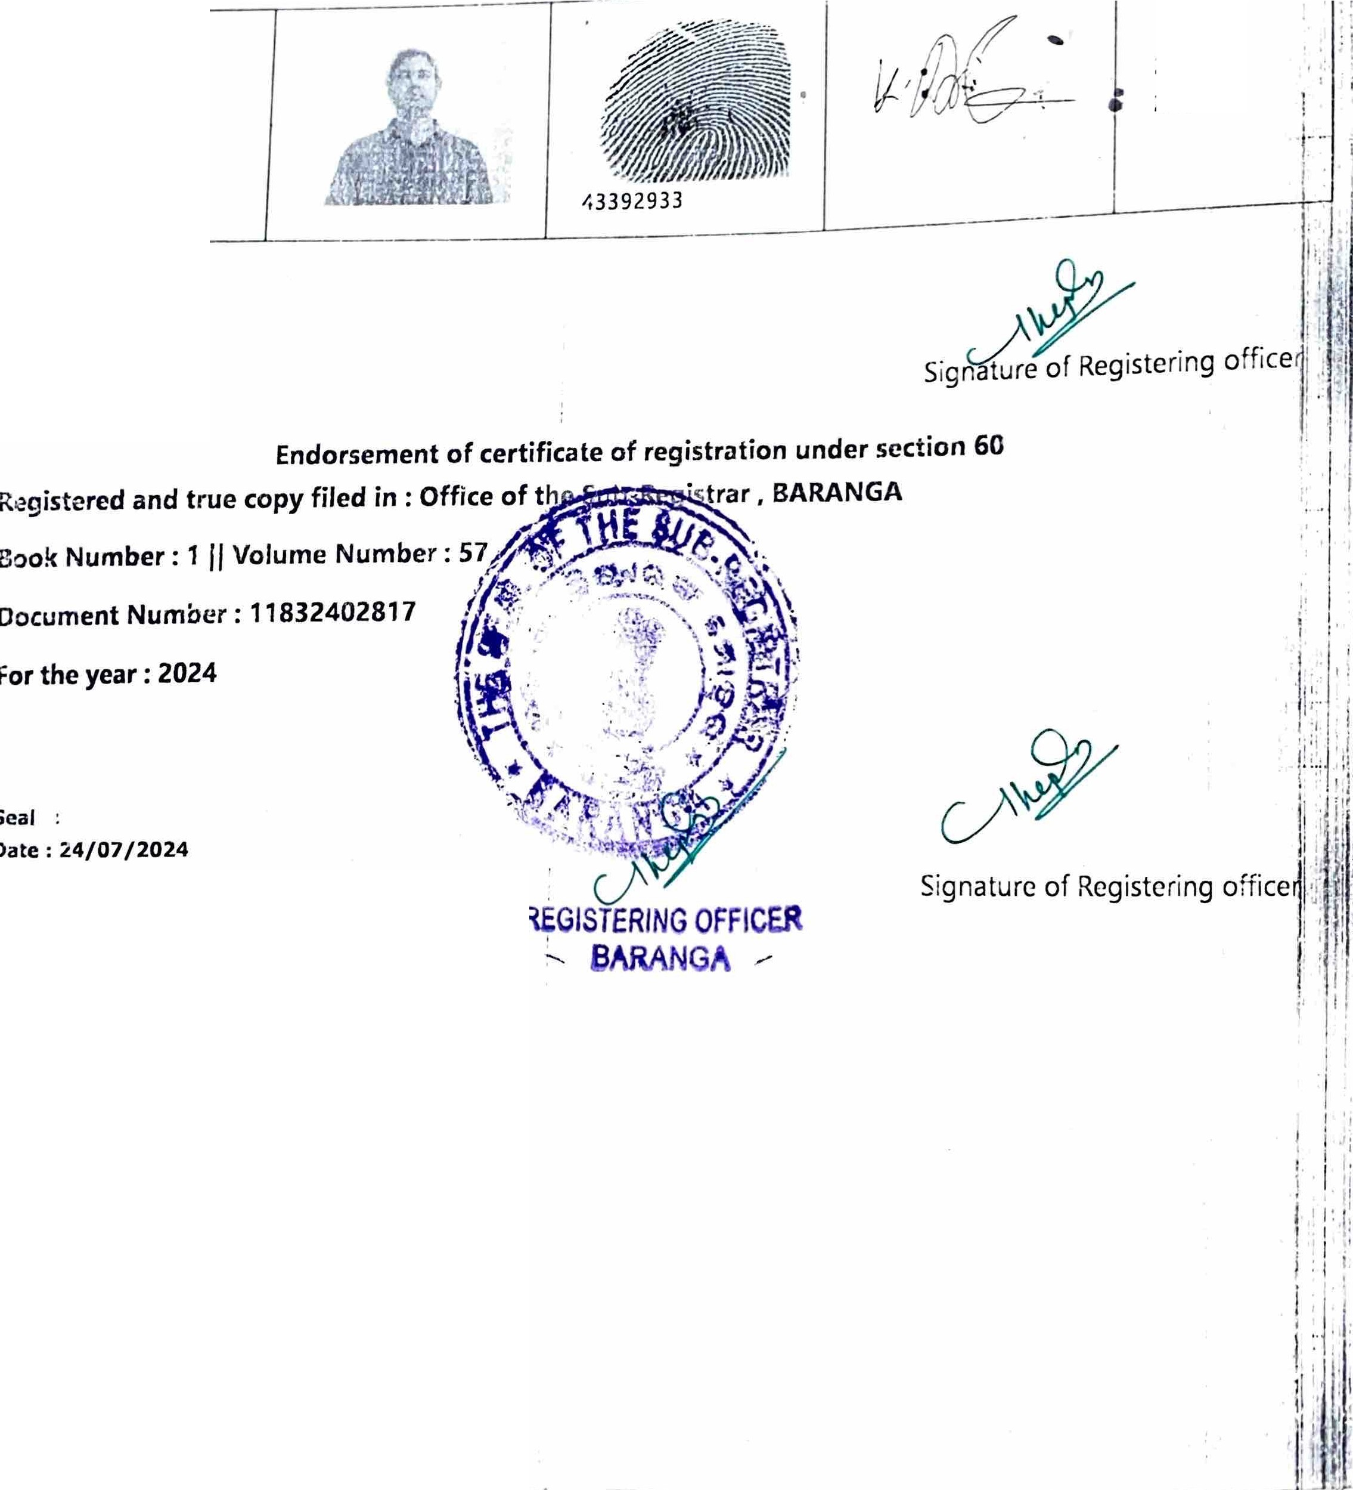

**Date: 22-Jul-2024**

*:>*

'YZ>. -v)*?I*

*--ry 1v,i* -:>\

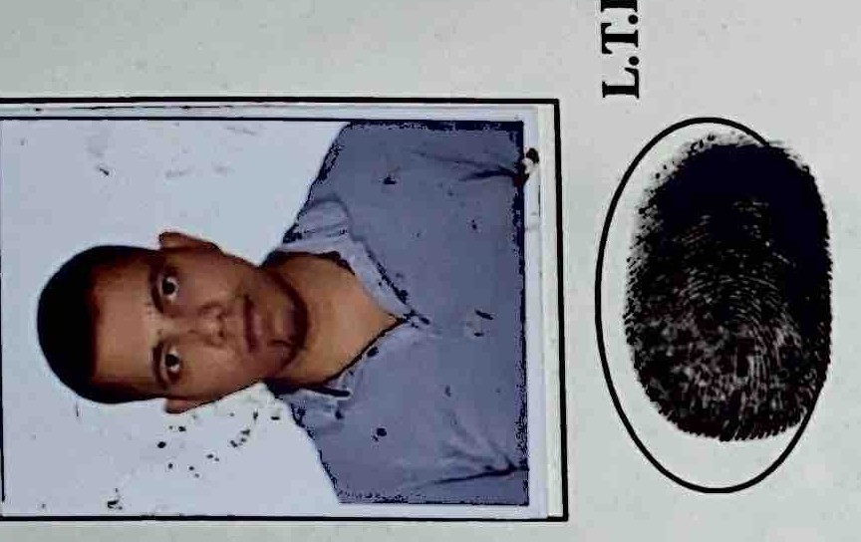f

4J--UO

"' 04 *"-)-f P o wf/*

'

## 4-z.-t.o-

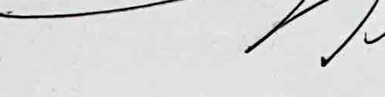*7J{/71*

*'CP* f

(*(p* -:- *(p*

*(p* <0> *(p* •

*a, (p* (p_Q:; & *(p* ((p -

Q tQ; c;:: *G7* (p *(.0 (.0* Gr °' Q;

& ·-

G,\ Q1

<0>

Q ((}; CJ= *(p* (;:: UJ -a *(p (p*

CJ>

*r,..*

)o CJ=

(ii>

*'(3F* @ ce; -

*a,* tur G3 Q:: @

(i;l *.J*

0 *(p*

**VT** •

*<.o*

C?

U= (pl (Q:: v

(D j

"i'\ 0

**o/**

*r,.*

@ *G1* <Q; & Gr Q; *a*

((pl Q:: *G1 Gr* Ql ._ ( *(.0* ((p *(p*

\.J=- *a* & @ *(.0@* eJ °' Q::

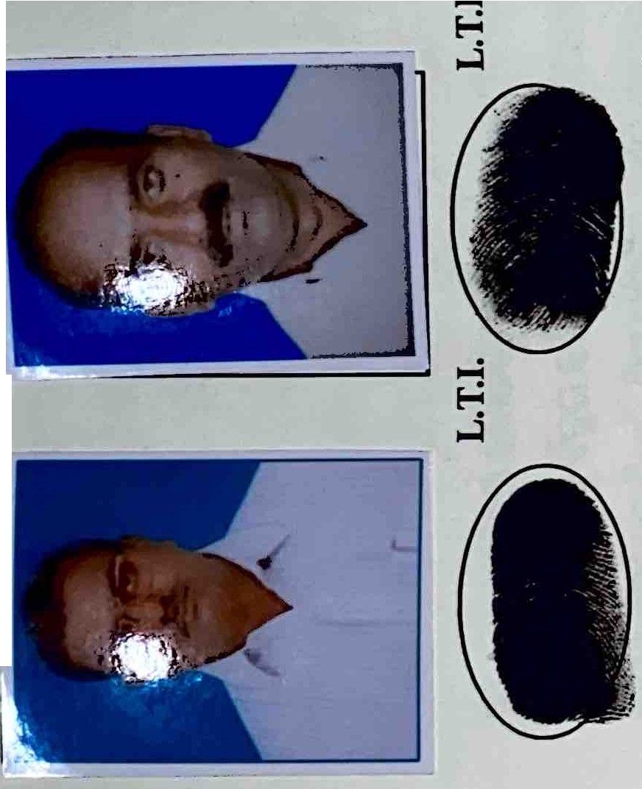tpi

l

(D,

N

'&

*j*

9' (

**0** (;) *r,.*

* *(.0* '->'

0 c;::

9' (

e; ca •

Gr cc;: GJ

((;) (G7 0

CG73 CG> 0

- *(p* (§! Q *G1* 0 &

& eJ c0; 0r@ 0r.eJ <Q:: <@ 0r *a a,*

Gr Q:: *(p (p (.0* .!..! *(p (p* ((p

*a*

Gr *(.0 CP* c Q:: *(.0 cP* &

C, *(p* (pl C;Jid CV & ca \'Q, (p Q:: :)(Se

*G1* '->' <Gr - eJ c;:: u> *(p (p V'I*

fgl

*\!P* (1) ts/ EV Cpd• (Q; *G, (p* (Q:: (p

*a,* <Gr ((p *(p* ( *(.0 (.0 (p (.0*

CJ>

(i;l

(D

((p

*'CP*

-

(;)

*\!P*

*(p*

(l'iP

l

(;,7 <G> \f(p *G1*

fJ/ UJ(;r

*(p G*

Q; °'

*(;JI* (p ,. ,i

*(p* - \.J=-

*(p* c;:: *(p*

2- 9' Q; ((pl

eJ (pd <Gr

I (Jr *G{* Q>

•• ,-., e;Jd <*(;JI*

*\!P* (§! *G1 a* <& rg1 @ & @

*(.0* °' < <cP Gr t *cP* cv *(.0 cP*

*8 w* o *a* L

Q; @ *(.0* 9 *(p* c;::

(pd°' *(.0* <Gr <@ *(p* Q:: *(;JI (p*

G:> c;:: *(.0* (;J/1 v,- *(.0* - ur *w (.0*

<C?S o_ @ *G1 tsJ* < @ *d* c;:

CQ:: *r:t,* cv <G> Cpd (§! *(.0*

Q *G7 G* Q:: '.:<J O t @ *w* Q::

(j; • *(p* - *'->-' p a, (p*

tg ff

I

&

a,

(i;l

J Ci5 *ca o·G1*

a; ca o

3

**Q1** cc;: 0 *r,.;r*

((p *a, r- (p* • • 0: *p a* ((ii> c;: *(p* (Q::

((;JI Q:: *r;:::,* v- *(.0 r,.* - ur T"""li er-

°'

*(.0 a,* g *(* *p*

Q;

9 eJ• U-' *(p* (Q G: Q:: & v- *(p*

* • (p Cpd *G1* l G: *(p G1 (p* O Gr

(D

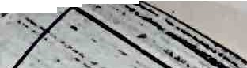

J

((p

9 (0;

j

(G7 °'

<G> *G7*

((;I/ Q:: (e;J (§! ((p O *a,*

*fSI* ts/ '.:<J eJ *G1* ts/ ({p eJ G: *(p* °'

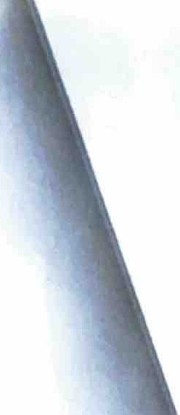



'

/

/2"2. l..L -

-(Ci) *cw* o7 *"J\.*

}J)'P' ,"'-1) r.,-rt \'!J') \ hta -iz

*/* ***r,I'*** *'vrl'b* ***1P****f19tj*

*I{///*

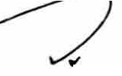

-

0;-d Gr

- *(;JI*

G! -

,

as-d *c;::"=* ..

- - c @

·;,-Ci 0: .. - 0: (j5

<GS (i5-d *(;JI* - <GS *(i* g

<Gr Gr *a*

c;: GS

GS & *c.o* Q *<CP* - c;:

Q; 0 Q; - Gr - -

* (;)1 *(.l)* (rs,

0, rs,

c @ & -

*w c.o (;JI* & GS & GS @ **9**

*QC.*

'->' -

GS &

a, *c.o* EV c;:

>G5 '(

GS GS

*i*

GS cu= c *c.o* oJ' Q; Q:: o, crs,s c -d & ._,

Q;l

Ci rs,

*'io'* Ci Q O>

***(.l)* er-** . **Oi-d**

;,(G(;JSI

O>

(

<GS

Q;

a

rs,

*c.o* - GS GS *c.o w* .. Q; Q;-d -

<@ rs, *(;JI* Q; e,. Q; <GS (j:: CO> <GS C@

*CP" (;JI* GS 0: Q; *c.o* c;: *(;JI* o

CQ;l 9' & (;r U: '((a" U: Q; rs, 0

C& - oJ' GS G! *!'io* 0> 0: O> ..

(j:: ***C.*** (}; *Cfi'* J (j5 *c.,o* Q;l

C& Q;l *C.O* Q 'f5i7 rs, rs, Q; CO; *C.O*

Gr

*t,-d c.o* ( Gr - ((j:: (j5-d G5 a:,-d <&

O> *(;JI* & O Q; EV G!

*a*

Q;1 GS *c.o c.o* u: *c.o*

$el cc;:

**l..,..Jv *(.l)* 05**

G5 Q '<u­

=

- **G5**

*e.*

<GS

Q;

*(* *;J*_*I* co, *!'io t, w* GS c -d 1 <& '<'io' o

*c.o w c.o* c;: & a, <Gr Gr EV

*l'io* (iS-d U: GS cv' , O; Gr *c.o* G5

*w* O: Ci v

**CO: *QJ***

Q (;)1

ras,

*(;JI*

0:

c;:

*w*

(;)1

*(;JI* Gr Ci <&_GS &

0: *c.o* GJ rs, rs, *c.o*

a

GS Q; 0: & O> G! Cul

GJ EV GS *c.o*

co, GJ rs, *Pd c.o a<@*

GS O: *c.o*

f5J

EV **O>**

**u,· Oil**

Q *(.l)*

c;:

I *c.o*

I 0:

c;:

G!

GJ

CO>

GJ

*c.o*

*w* Q; 0> U: GS rs, '<'io' *c.o* Ci GS

<GS *c.o* <O: GJ @ & *oF c.o* O>

a *w*

Q; & *c.o* a (i)dcrs, < *c;::"=*

*a<* GS <GS < cg & Gr <O: ca

Q;,, Q; ( & O> (;JI((}; *c.o* (j::

Gr *c.o* 0: '<C"a" u, • <GS *c;::"= c.o* GS <

'( ,, -- ( -d (j5-d 1 '8; Q; rs,

Ci§ c;J **rs,** *c.o* (j5 (Oil

w (j5-d <Gr rs,

Pc - (};Q o *a*

Q>l V' J ._ CP - EV & G5 Col

*e.*

c;: Q EV G5 9' Oi

,::::- U:;,C.O 0: 9' O>

**Q Oil**

*(.l)* O> Q

EV *o,-* EV

0: O> Ca

*(.l)* Oi *(;JI*

c;:

*(.l) (.l)*

*w* GS (p

*w* U: Cul Q; (Q:; Pc U: C& *l°io*

***CB*** c;: *c.o <(;JI a,-* - c;:,;

**0> Gel 0:**

0: G*w*r

*c.o* O>

G*w*!

cg;

*l'io* GS

Q;1

-

<GS

Q;

u: GS

GS

*c.o*

c;:

rs, c;: O> <O:

Oil *(p* &

GS

CO>

*c*G*.*S*o*

GS CrO>; Q;-d Q>l c*C.*;*O*; <& GJ Q; c;: Gr - *=s-*

Q;-d C!'io G! Or'

**(j5 EV CO> C o/ ffi g Oi@**

**re Q;-d (rs,B** (}; **Gr EV *C.O* (j5 GS 0**

*(.l)* O> *Cfi'*

*0,-* rs,

G» eJ; *v w* <@ o, cu: *w* _:/ aJ

GS - *w* u: O> u: c;:

G***C.0*** S

-*C.*

Q *c.o* & - 0:

Q 05 G5

r0s:,

GS

**Cul**

0, c;: *c.o* rs, Q;1 ,, *c.o w* Q @

(j5-d G5

**Pc V'** (@ **(;r**

***a***Oi <& (<}G;r

EV c;: Oi

*c.o*

*a*

GS a

& - *c.o* _ u: *a c.o* 0: u: 0> Gr *<CP* -

*a=:,-*

c*a*a *a=:,-* Gr>

-Oi Gr , _

*(p* Oil

- *w* & G! Cul *l'io* U: G! _

GJ u:J er u:J Q *a* Oi

EV EV

***(.l)***

0:-d Gr

O> rs, ((p <GS *cw.o* O> GJ G! *c.o* 0: *c.o*

rs, Q; *w w w* GJ <& Q;

(

<&rs, *w* <& <&

(Q;l

GS 0>

,(c;:;JI

*0,­* Oi

((jS

*(.l)*

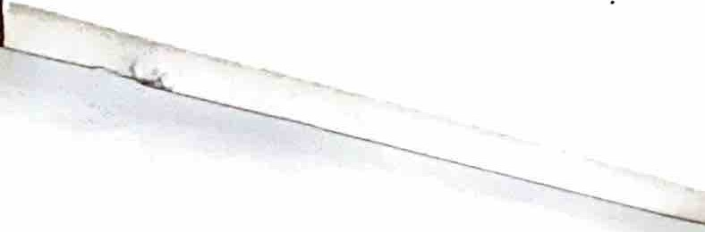

*(.l)* Q (



--"ts.) z..-z.

'=--· *t<>* ,,--z T'I,->*J*

)rv. ,v-n /'P ,) >\

4-v{.• *--L---t->*

*£z., t. ..* ---i..r!, , *,r9ol -crtV v1*

*J f(fl ll*

(Ci§ *=r* -

*O=* - ;,(;11-d

G:>

Ci§ Ci§ *"CP CP*

(Ji G:> (*(;JI*

'.:<J Ci§ 0l

Ca@O>

-**S!)7**

0-:· -GS

*c..o (p* -

QCa G*c..*S*o*

<QGi(S

*c..o c..o*

Ui ((;JI G7 cv'

- *=r* Qi

ur· GS

GSOOi&v­

- -

**C& *Gr***

c(Gj: S

G» Ci§

05 GS G7 ..

Q Q

*c..o* &

*;uJ c..o* Cu> GS

1 ( *c..o*

*c..o* Ci>

CC> & e:>7

Oi <, *a>* ev G7

G:> r{p - G:>

c,1 ev u:

U: '.:<J

*O> G1* Ui

GS cG7 *(;JI* Ce

G:>

>E

Q1 oo Cu§

Qil ali (Ji ((;JI

IQ *(p* Ci§

**Qil ((II G1)**

*cP* Ci§ Or GS

GS ;,C(;JI *CP*

U'

(Ji

Q

*e, c..o*

Ci§

-

*v,i· e:)7*

v= *c..o* u,v (p *G1*

*c..o (;JI* ((j:

( (p-d (pl

# g (

*c..o*

*G1-d (p*

(p -

*GS O=*

Ci§ Oi

(j:

U:

<& Q

ev Q '<:P

& *e,* GS

*cP* G:> G» "03

81 -***c..o*** or

*C1!* ..

*c..o r:tb* &

& G:> (;)1

a(j:a (-

0l "Oi (Qil (;)

GS *r-* ((p Qil

(;)1 @-d 2...

*e,* (G7 (Ji

*(;r* Ui (j:

asd Q *c..o* u: *cP*

ev G7 CC>

&V Ui -

Qi-d .. *(p*

Qi-d Q G1

;,C U: CC> *r%*

Ca Q

05 *e,*

*e,:r G1* <v- *c..o*

(Ci§ *(;r* & ((p

- u:

&

(Qi

G7 ((j: u:

(Ji (G7 (1!

& Ca *@*

(II fg ev O GS

&

(Ji. GS *c..o*

0: (Ji GS

<@ 0: GS

6: & @

G:> 05 *GS* UT

((j: *(p*

*e,:r G1* cv Ca *C1!*

Ci§ GS GS

- GS G7 -

u: (j: *c..o*

*G1* .. -

Ca Q GS

<GS

-(jiQ-C..O

&- ev *(;JI* ev

ea caa

Ca *lW'* ;,((;JI

Q Ca G:>

1 ev.

*c..o* GS *e,*

*\P* u: *(p* u:

G:> <& *(p*

*C1!* - -

u**(1!**:

ev

G**(j:**7**1**.J**1**

Ui G»

**ur•** & ***(;JI***

;,(

##### cf c

(;)1 Ci§ *c..o*

IQ *=r* GS

Q - *(p*

;,((;JI Ui

(p Qil *GS* - Ui

*c..o* . *c..o* ;,(*(;JI* '.:<J u:

*CP* ev O:

*GS (p* -

- GS

t Ca

*c..o* ((p (Qi *(;JI* (

Ci§ .,,Ci§ cv

Q G:> G:>

ev *<CP a> CP c..o*

**..--.I** -

- Ca *(p* ( *Gr*

-*cP CP* - UGSi

Ci§ , Q (j:

*(;JI*

G:>

i

<GS *CP*

*a,,* & cg; 6:

Gl1 caa *c..o e, G1*

*c..o* ' ev

U= Q1 ((p

C..OJ *@* 6:

ev ur <,

Ca *c..o O=*

*(;JI* G:> -

Ui (1! *e,* Ci§ 9'

Ci§ *c..o* (Ji u:

o. **U)v**,,<Oi ev

*"'CJi @ @*

-**(j: 0**- ***Pc::.***

((p 05

*c..o* GS *<CP*

*e, c..o* G»

*cP a>* ev *"<P*

Ui ;,((;JI

GS (Qi <GS *(@"* (Qil

*G*u:*1* 0-

*c..o c..o* u:

ea ev CP *e,*

u: (Ji **vr**

*(p* O &

(Ji <GS Q CG7 C(p

V' G:> (@ (1!

(1! (j:

(j:

*O= <G1* Ci§

- *(p*

g

& < <GS

*(p* -O: - *(;JI* G7 ev

*@* ( (Qil

<G1ll GS ev

or

G:>

<GS u:J G7

*(;JI*

G:>

ev u:

u:

*<<P*

*c..o* (Ci§

Ci§ *c..o* Q u:G1 U:

(j: *(;JI* & *G1*

05 GS ev <Oi

((j: GS

*c..o*

u: (j: ((p

GS 0: G7 Q c..o-GS *G1 (pV'*

Qi-d

*(p*

((2: <GS

ev Oi

*(;JI*

Q

Q U=

*c..o*

*u=-C..O-(p*

*C1!* - GS C(;JI

ev gGS

*CP* <GS 9'

(j: (Qi Ui G» -

*c..o O=* u: Ui U: GS *(p-d G1* GS (1! (Ji <GS - *c..o*

*c..o O=* Ui *(;JI* U=

0 05 ((p

(j: -

C& ev (II

05 GS *GS*

- *c..o*

ev *<<P* O:

*@ c..o*

G7 (Qil Ui G» ((p (j:

U: *(;r* CG1'"

Oi GS

GS Ci§ *a;*

& cc,

((p & QI

- *(p*

& *c..o* -

ur

(II <GS

Ui Ca

c;, G:> ev

(Ji Q (II ( *(;JI (p*

0: 0: GS (Ji

u: *c..o* 0/

<GS Ca CP

Oiev-Oi

;u'<& *(p (G1* Ui

GS Ci§ §' U:

*<P cP* (j: CC> *(p*

- <GS

**1 Ui G7**

*c..o* (@

GS 0:

Q (p *(p*

ev *GS* ev

- **0l** (@

**(Ji** GS 0:

<GS &

Ui *c..o*

*=r* <&

- *O=* ev

& &V ((II

&V as-d (p-d

*i*

G:> *"CP*

QJ

:o' cv'

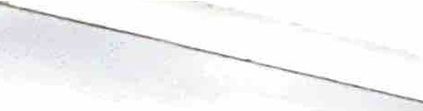---

Ct,Q(j:(Qil

ev ev *G1 <CP*

f; ev u: O: G:> (>1.8

*G1 G1* Ui

*GS* Q <&

*GS* & *c..o* Q1 <&

(p S!)7 *(p*

((p 9' *c..o*



t· ,.

• •

*, :'* , .

.

·,

'

\

;

)

l

... I

. . ,

:, •

*,:*

" ..-,. .(.'.!

* *::;* -

*... -:. 4'* • '

,.r•, ••• -

' **'f** " •' " ·". '

_;:-

\

•••I,♦

,.r.•'1-

I

*I*

•

*j*

. l

•

RiOISTER/NGOFFJCER

**BARANGA,,,.-**

*'"'U'f "'-*

n-v-- 1 *n,19.>i* '$>>1

*iu*- *VI/ Q;t 'vlf-V 9'f791J*

◄ .

*-loo l>*



Oi @ C(p CC57 - *O=*

*<.o* Gr C@ *CJ)*

c8;

GT O:; >Qi *(;JI* U:

CG':> -d *@*

GT

o»

Gr *<.o*

8

*f/1/J*

*O= fip* -- O> ((p *(p* --- G':> G':> 0 6::

:v' CQ> ***GI*** *(p O;°* C -d C(;JJ 1 *GC'f\;fl*

*;JO=* ev ., *rs, <.o* °"' GJ

cv'

*V*

*(p* re;; *CJ) O=* G':>

*CJ)* C(p *CJ) (p* C(p 1

*(;JI ,(;JI* c

u: *CJ)* -

C57 GS

*rs,* Gr

*r::=* .,. I *(pr-,,. r,o @ (p r* ..

- ( 1 G3 *\.>'* \.>O v,. ---

(jj < ; CCP r§ c . ·o. c *CP*

(($8

ev

(p

o/ C G':>

v, ev GS

ta.. **a**- **,** Gr • • *<.o* cu: Oo

O:; f;Y- *G* Q

*(p* - *(;JI* a?

(jj G':> 1

ij *(p*

*CP*

*(p* C57j

*CP <C51*

cv' CQ>

°'

ev -..-

*·@* 0

fr

*<.o*

((p *<.o <O=* c (pl *<.o*

*g*

cu5 *:vt* ev

*CP* GT *<.o C51* ev

*(;JI CJ)* C(p

*<.o* u: 0,1

*:v1*

@ *(p c..o O=* c ((p :::::: *(p* - (P. GJ

***(p*** • *(p* ***(p*** ,-.. Q CG> Oi CP f;Y- CQ:>l

C57

(p -

o

GS C(p ev CG>

**((p**

U- : *re* CCCG;7>8

cf *r:::.* ev *r,,* er-, ,..... ·

*<.o a*

(;> **(C57 C l (p**

CO= *0=* "cv Gi

### fi3ua:

*r*v*-* -Gu,,? ((;r -11 • '->'' *<*e*.*v*o* ""' r"1 *G*

*t;l* (p

*<.o* u: *((p* a, *CJ)*

G3' *CJ) CJ)*

@ *c..o CP O=* G>

G= *V'->'°"'*

u5 - *CP*

- !)((;,/ >Qi - *((p*

, **GT G':> v, :>((;JI Col c**

Gr u: *Gi'(p*

*(p C;> C;>* CC57

co; • cv' ev *<(;JI rs,* c

*(p* (C57 *(p* ...... *rs,* G':> Gr

GS *O=*

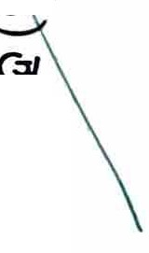CP *rs;:*

°'

• •

1 (p

((p *(p O=* u: c *<.o* ((;JI >Qi Q1

cg;

u5 :>(;,Id u5 v,

*rs, O=* ( 1 *(p (p*

Col ((p *((p CP* GJ

- G':>u5

:>(;,Id G':> - GT

*CJ) (;JI O=* ( c cv'

*<.o* 1 *V w*

*rs, CJ) (p*

0=-d *((p <.o*

*O=* a? *CJ)* "U:

(jj *<.o* u:

ev ev 0=

((p -d -

Gr *(;JI* GT-d *<.o*

*(;JI <.o (p* cv' <C571 °' .. .,GTJ

***ol*** *ol* o, GT a,11 *V* O G> Gr &== lis5 GJ G,/

*ci*

(JI u5 *GI* <Oi 9' G> *0= <G1*

*w*

- *(p* (;,/ - - *(p (p*

*Col u* u5 *Gil* Q £ti <GS G':> (P. <GT U:

(j *(;JI l'i9 @ (p* ( Qr.:> f;Y- -d

( C: ":?- (;> o/ Q J (Qil 5e.J

*\>I 0= v- Gil 7* u-- *<.o* CQ> 0 <GT U: u>v

*<.o* Q

*<.o*

C57

*(p* "G:

*O= t;l*

u: ..

G':> Oi

Qil ,.

-d (pl (jj u: ((p

O:; G':> *(;JI (p* @

c-v *0=*

(p **l'(p** "-" *r:.* U: 0 *(p* • • U= ev ( g

cu: *(;JI* cu: *(p*

re;; *(p*

### .. cv

- a, C'-P G':> • G,/ *(p* ,.....

*(p (p*

O:; *(p <.o w* **(($8**

*<.o (;JI* - *(p*

Oi *<.o*

*GI (p <GsF* O:;

°*G*' -9' GS *O=* ,.._ ev

*<.o <.o*

**( 1 <Gr U: c**

*<.o (p* Gr

*O= O=* (

CP *(p*

cf ((p (;,/

o u5

L

CP .,......,i • •

Gr *(p*

-

'->',,.

a&

( (Q>

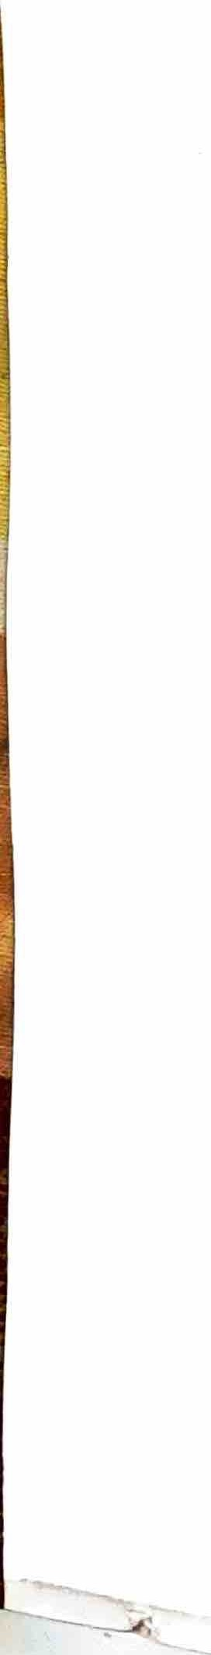

-•·

C(p *(@" (3"* -d C(p

- *(p* cu: *fip* GJ c *w* O:;

*g* .,g; f

*<.o* Gr *<.o*

*(p* **(o\** u: w <&

*(jE* 6== L a, 0 ( *':=::* O:; (Qil f(p a,11 (Qil

CG; *0= rs,* L 0:-. *V 0=* GT ii <GT *C..O* Q1 *ct,* <GT

Gr G':>

((;,/ ((;,/

*V r:s,*





REGISTERING **OFFICER**

BARANGA,,,.---



*I*

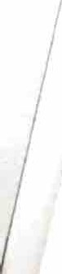-6-

###### 16a Q6 glY116 (3 6 g1gt}'Q@ q I§ Gi'rtl Q£J @Q QY§

***\:I*** ,..., *<*

###### 6gliI Q @ Qg Q Q@ Y1 6Q QQQIQQ'Ol6J.. £lfu'11Q 6

,..., "' ,..., ,..., ,..... ,...,

###### 21Q@ QQgliI Q 6Q6Ql@Q QYl Q' tJ Q £1Q£'1

***\:I*** ,..... ,. **w**

###### 62 I Q @ l6aY116g qQ1g 6 21Q@ QQgli I

611 Q fll 9 o **9 ls'** flijil I I 1f1Ig_-Q l Q

- *fl* A, 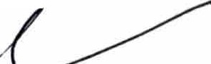

Aif

*rJo* , *Nf'ri'{lr-* 1JJ!J'.l -

***f<in (v, rvr*** *I* ***V1's t*** I"! **\J,,, -,-J,l.l**

-f ) *\.<"'-'"'µ,.'->* °2!2..6).

**\lrk4**

Q6 G'lfllg_- l Q

..

*9.f b-lJ+-f.A... YO.JV/*

*.Jft;* 5) f>1I' .

***A-[fc-*** /?

;3 ,

#### *oH-*

*7-=>--ezVL,..J-*

*--<-*

**<2ll<o'9 6'cn'**

a.J\tn\ JCU) ?

6 611_- l Q "'--47J-r

,

###### Q6 g1 6Y11Q Y12Gi'@ § QQ Qy'lg QY!lg Q6 g1Q'

*<* ,..... *<* ,...,

Qf.!g Y16g 6Y11Ql YIQQ6Q 6YII *g6Q* Ql6Q 6Yll IQtlij

IQI £'1Q£1QQl IQ I g1 00@ Q g QYllg 21Q I Q@Yll Qi6 £1tGIIQ IQ 6Q I 6Q Qy'lg Q@QYllg t

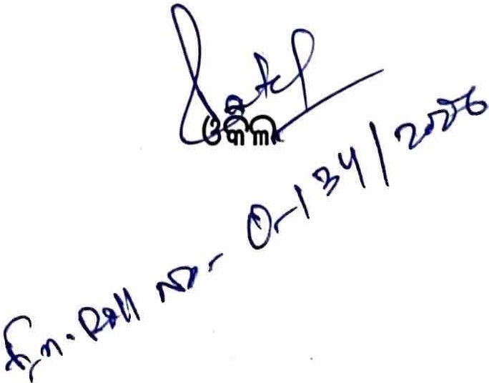QYl@ OQ, f_!QIQ Q2 Q@ g QG@ I

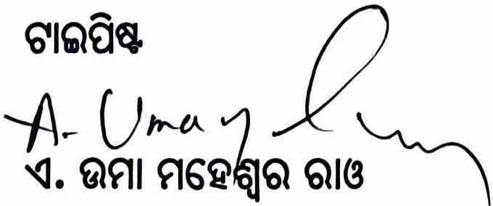





.J,,1,i,1 1.

. ,. t,.r•>"":·{·. :·*:·*

,,

'

.\ *:*.*.*

I

d

t"..

\.•··,.

* *I*

*I*

REGISTERING OFFICER

**BARANGA***.r*



-7-

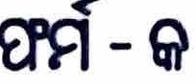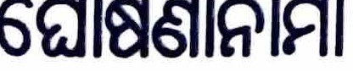*I*



##### IQI 16AQGQQIAl6h'(3 6 16Qla611 6 Q9 Q

Q QQ In) @ QI 6Q 6 Q QRQ *Q* I Ki' h'IQ I ,€JO

£100@ R.e.GQ Q QGQ *Q Q* QI 6Q *§ Q*

##### § I IQ e!QIQ Rl61A6fu' 6Q6Q O b].6tl 6WQI Ql Q I

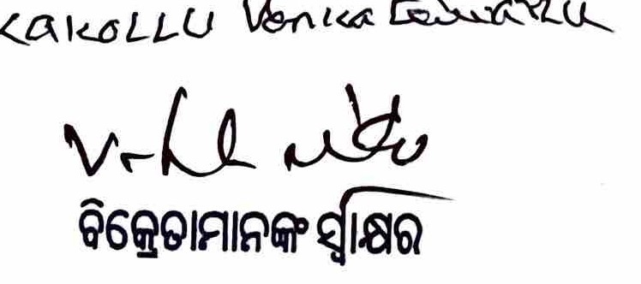R.a. R.a.t') &wcu'r)

##### 6 1 'Jl8Q





**REGIS**

-.. s

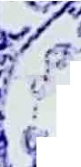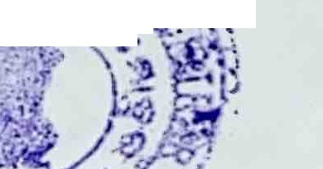

<*; l -* ·-.

, ..

,1

I '

. ;'

*""ii,',r-*

.

\ ..

*VtAsHE-£7,1\/0I*

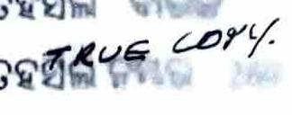*p s. Cu T .T****4*** c.ff *s A:::D***Al{** Na **3-?**

* I *'J)IS,T- !P"'*,4t::.../f

*SCA LE";J', ''.:::-Im/LE*

*Y£Ptf?-l7* ,-$

I

N

I

0.00

0 167 0.20 I ER

I 0.L . 8 (A) 6

o 6150n02J

\11Q 'o1199 6

0

*1*•*/*

f\r'

)' .:i.

I ; I ,.

,)(1. *fJ* • *ll* **l'Y** *I* **tt**

· *07,:;u*

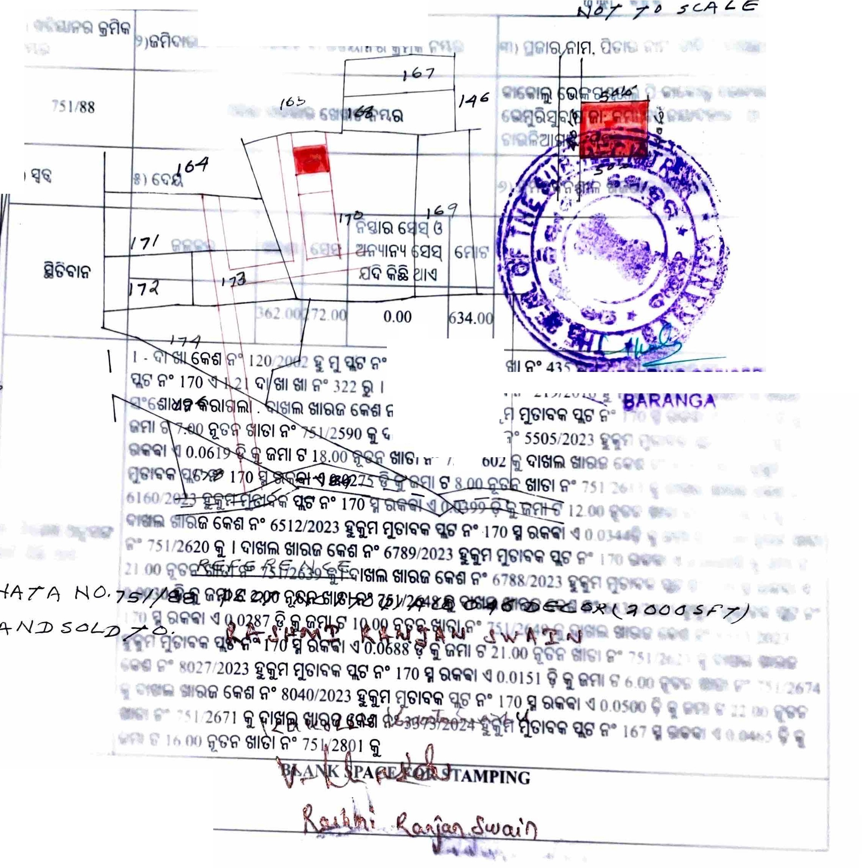

I

|  |  |  |  |  |  |  |
| --- | --- | --- | --- | --- | --- | --- |
| : IS l8 hrlR l alSI  : 18 8l% Gl.3 12'  **!>NldWV.LS HO.!! 3)VdS )I.NV'l8** | | | | | | |
| 3 1O8Z/ISL.81811S 8&8 00·9181135  3 *§ S9vo·o* I;\ l ee l91088b e l8'°C313ei *vZOZ/£l££* .8 e9 6\SIIS 131SI"' e IL9Z/lSl .81811S 888 *oo·zz*81136 e § ooso·o (;\ 1 ee *oL*1 08 8b e 18T3 13ei *£zoz1ovo8* 08 e9 s1S1is 13is1"' e  *vl9Z/ISl* o8 l8l1S 888 00·9 81135 3 8 ISIO"O I;\ l ee Oll .8 8b e l8'°C3133 £ZOZ/LZO8 .8 e9 6\SIIS 13131"' 3 £Z9Z/1Sl o8 l8l1S 888 OO"lZ 81136 e 8 8890"0 I;\ l e\5 Oll .8 8b e l81'3133  *£Wl/£l* S9 08 e9 68l1S 51SI"' 3 6v9Z/1*SL* o8 l8l1S 888 00"01 81136 3 8 L8zo·o tl- l e\5 *0l* 1 08 8b e l81'313ei fZOZ/6£89 08 e9 68l1S 51SI"' 3 8v9Z/1Sl o8 l811S 888-00"Z81136 3 8 orno·o (;\ , e\5 *0l* I .8 8b e l81'313ei £ZOZ/88l9 08 e9 68l1S 51SI"' 13 6£9Z/ISl .8 l811S 888 OO·1z  81136 3 §8890"0I;\ l e O0l8l 8b e l81'3133 *£ZOZ/68l9* 08 e9 6\SIIS 51SI"' I 3 *0Z9Z/1Sl* 081  18l1S 888 00·01811353 a»rn·o I;\ l ee Oll .8 8b e l81'313e £ZOZ/Z1S9 08 e9 6\SIIS 131SI"'  3 v19Z/1Sl o8 l8l1S 888 OO"Zl 81136 3 § 66£0"0 tl-l ee Oll 08 8b e l813133 £ZOZ/O919  08 e9 eeus 51SI"' e £19Z/ISL .818l1S 888 00"8 81135 e § *SlZO"0* tl- l e\5 *0l* l 08 8b e l8T3  133 *£ZOZ/l9l9* 08 e9 68l1S 51SI"' 3 *Z09Z/1Sl* o818l1S 888 00"81811353 § 6190"0 tl- l e\5  *0LI* 08 8b e l81'313ei £ZOZ/SOSS 08 e9 68l1S 51SI"' 3 O6SZ/1Sl .818l1S 888 *00"l* 81135 e 8 *6ZZO"O* (;\ l ee *0ll* 08 8b e 181'313e £ZOZ/OSI9 08 e9 6\SIIS 131SI"•' 113 1\Se 8Rl 9.13 1 81S £) 1313 818l1S e T3 3 9I OZ/61*z* 08 e9 (y) 8 ")fTO I @: *ZZ£* .8 IIS IIS I"' I *z·*I tl- *0l* l 08 8b  T3 *ZO0Z/ l* 1I 08 e9 IIS I"'· *Z* I @: *S£v* 08 IIS IIS I"' oz·o tl- *L91* 08 8.bT3*i ZO0Z/0Z* I 08 e9 IIS I"•' I | | | | | | 1  cl5l38 ::  - |
|  | bo-v£1 | oo·o | bo·za1 | 00-z9£ |  | 81 § |
| 81139 | tl-l1'2 B  I'13139 h8lh812  £) '13139 81 § | I'13139 | 1 61S | \Sees |
| u ea 8l SIS 6U 8 8135 (6- | 'OM ( | | | | | ii 13 ( |
| e8e ' a l12§\%  - 112 ' 815 1"38 :1a 1131' :15 *Bi*1a°B§T3 9  l'Bh3 9 l1'913:!} 8'1,85 9 le9l3 | 8't38 8l IS9 e1e8B I §£) | | | | | 88/ISL |
| 8l!!Bla-£) 818 '1318 818 '1318 818 ( | 1 8't38 e 5 1581-0§IS 18 8IN 9 £) 131858l"'l26( | | | | | 6I1e1.26 e81>eo'its3*(* |

1'83: I §

*69Z* : 8'138 5 8

.ae1 : 5 58

*c*

*v£* : l5't38 1a112

e B e8e : 1, 112

lla l3M: 16 9

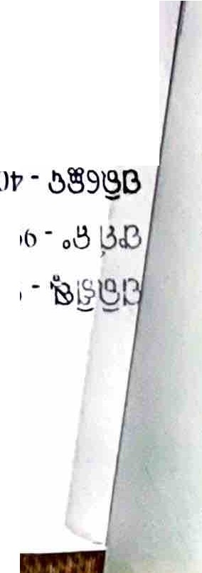

**81B§lS**

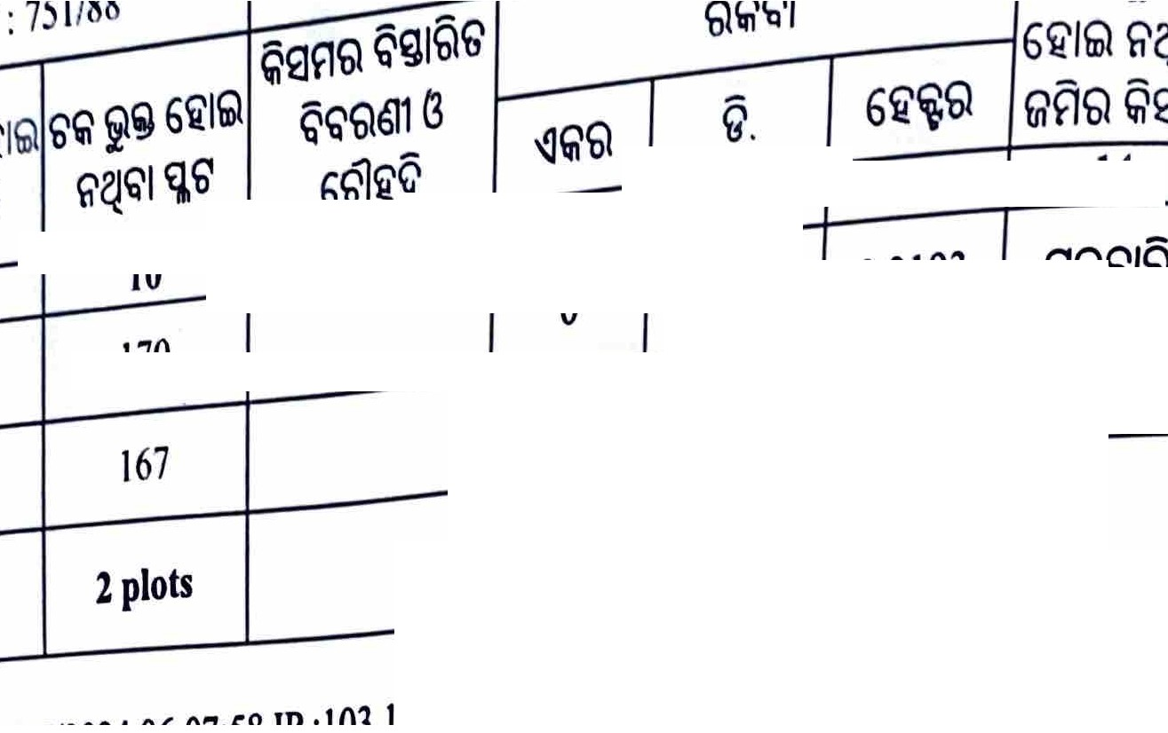

li'"Q flQ

b'

*6 /*fu1 b'" *6i/Q*

*8*

*fJ I 6'*

*9*

*fi'fJ I S*

*10*

*170*

0 Q § /QS Q ,

Q611G

*66'1*

***11***

*Q*

*§.*

*n*

*6 Q*

***13***

*0 7890*

*167*

*0*

*1535 0.0621*

***2 plots***

***0***

***9425***

***0.3814***

Q/ l£t f>'fi'I / *6"&' 19/07/2024 06:07:58 JP :103.165.169.52*

\.

Application No: 2024039010660

i)

@)

**Form No. 26**

Certificate Of Encumbrances On Property

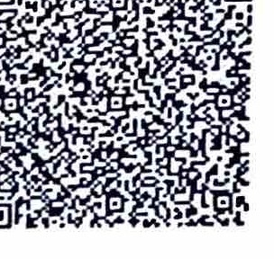

Certificate No : .EC03920240QIJ092

Applicant Name : *S* SW AlN Owner Name(As per Application) : KAKOLU VENKET SWARUL AND VEMURU SUBASH NAIDU

Having applied to me for **a** certificate giving particulars of registered nets nnd encumbrnnces, if.any in respect of undermentioned property :-

|  |  |  |  |  |  |  |  |  |
| --- | --- | --- | --- | --- | --- | --- | --- | --- |
| **SI.**  **No.** | **Village Name** | **Khata No.** | **Plot No.** | **Area** | orth Bpu'ndary | E st Boundary | **West Boundary** | South Boundary |
| 1 | **BElAGACHIA- 84** | 433 | 185 | 0.06 Dedmal (1000D•1Acre) |  |  |  |  |
| 2 | BELAGACHIA - 34 | 433 | 184 | 10 Decimal  (10000=1Acre) | ' |  |  |  |
| 3 | **BELAGACHIA** • 34 | 433 | 176 | 0.46 Decimal  (10000-1Acre) |  |  | : |  |
| **4** | **BEIAGACHIA** • **34** | 433 | 174  I | 0.38 Decimal:  (1000()...1Acre)  : '  .. |  |  |  |  |
| 5 | **BELAGACHIA** • 34 | 751/193 | 17615572 | 0-=··  (1•.·,:,Acre) |  |  |  |  |
|  |  | - | * • I• • 1   *:.* .. | ' |
| 6 | BELAGACHIA • 34  I  ' | 751/193 | 174J5571 | j),0070Decimal'  (1 jl'\,c.r,e) |  | - |  |  |
| 7 | **BELAGACHIA** • **34** | 751/193 | 1841.3207 | 10DeciJnal  (10000:t.Aae) |  |  |  |  |
| 8 | **BELAGACHIA** • 34 | 751/193 | 18513208 | 0.06 Decimal (10000-1Acre) |  |  |  |  |

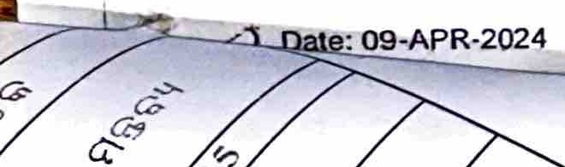

Regn. Office: CUTTACK

*I* **lignedb**

Date: .°cM }f:b s

*V*

.OS:30

. Signature of egistering Officer Page 1 of 4

--

*cft-W-*

\ ' v- t-· - _,.,r;;:,'2*t*-*i.* / 174/3205 0.3409 Decimal

...,,,,,_,_

. *751/193* (1 1Aae)

\ .-·

*IIELJ4GACH/A* • 34

17613206

0.46Oedmal

*--1'1* 1s1n93

*11 I* SELAGACHIA • 34

433

(10000-1Acre)

176 0.2330 Decimal

(10000-1Acre)

12 BElAGACHIA • 34

|  |  |  |
| --- | --- | --- |
| 33 (10000-1Acre) | | |
| 433 | 185 | 0.03 Decimal  (10000-1Acre) |
|  | 184 | 0.05 Decimal |
| 433 | (10000-1Acre) | |

4

17<4 0.1930 Decimal

13

14

\ 15

\ 16 \

BElAGACHIA • 34

BElAGACHIA • 34

BElAGACHIA • **34**

BELAGACHIA • 34

751h208

751/1208

184

185

I

'

'

I

'I

.

I

0.05 Decimal

(10000-1Acre)

',

0.03 Decimal :

(10000-1Aae)

I 17 I BELAGACHIA • 34

BElAGACHIA • 34

\ 18

I

751h208

751/1208

17614235

174/4234

168

G.2330 Decimal

(10000-1Acre) I

o.1930 Decimal

(10000-1Acre)

0.22 Decimal

\ '\9,

l 20 2'\

22

BEV.GACHIA - 34

BELAGACHIA • 34

BELAGACHIA • **34**

BELAGACHIA • 34

290

372

751/192

751/192

171

171

168

(10000-1Acre) *I*

0..49 Oec:lmal (10000-1Acre)

0.3630 **Decimal**

(1000Da1Aae)

0.1542 Decimal

(10000-1Acre)

Regn. Office: CUTTACK Dale: 09-APR-2024

g ,• ttro::/;ARID

Dale: 2024.04.11118:0l:25

+05;30

Signature of Registering Officer Page 2 or 4

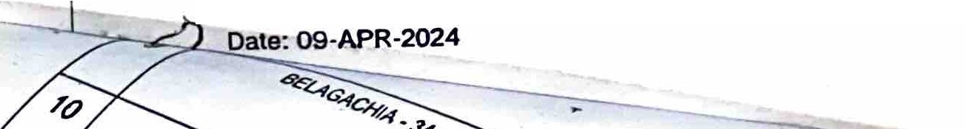I hereby certify lhat a search has been made in book and in the indexes relating thereto for I1 years 0J-JAN-1995 to 31-DEC-2005 for acts and.encumbrances affecting the said property and that on such search the following acts and encumbrances as detailed on the reverse appear. I also certify that save the aforesaid acts and encumbrances no other acrs and encumbrances effecting the said property have been found.

|  |  |  |  |  |  |  |  |  |
| --- | --- | --- | --- | --- | --- | --- | --- | --- |
| **SI.**  **No** | Registration  **Office** | Description Of Property(Village/Khata Number/Plot  **Number/Area/Boundary(East/West/North/South)/Chaka**  Numb r/Flat **Number)** | Registration No. | Excecutlon Date | **Sub Deed** Consideration | | First Party | Second Party |
| **Type** | Amount |
| 1 | CUTTACK | BELAGACHIA-34 I 290 I 168 I 22 Oismll Aae I NA I NA I NA I NA | 3681/1998/1 | 15-Sep-1998 | SALE | 3000 | 1-SRI TRILOKANATH SWAIN | 1-BASANTI SAHU |
| 2 | CUTTACK | BELAGACHIA-34 I 372 I 171 I 49 Dismil Acre I **NA** I **NA** IINDRAMANI ROUT | I 33512001/1 | 19-Jan-2001 | SALE | 78000 | 1-SRI | 1-KOKAW |
|  |  | JAi SAHOO&arnp;ORS |  |  |  |  | DEBENDRANATH | **BHENKAT** |
|  |  |  |  |  |  |  | SAH002- | SWARULU2• |
|  |  |  |  |  |  |  | SURENDRANATH | BHEMERU |
|  |  |  |  |  |  |  | SAH003- | S1,JBASH |
|  |  | \ |  |  |  |  | NARENDRANATH | **NAIDU** |
|  |  |  |  |  |  |  | SAHOO 4-GOLEKHA |  |
|  |  |  |  |  |  |  | BIHARI SAHOO 5- |  |
|  |  |  |  |  |  |  | FAKIR CHARANA |  |
|  |  |  |  |  |  |  | SAH006- |  |
|  |  |  |  |  |  |  | LAXMIDHAR SAHOO |  |
|  |  |  |  |  |  |  | 7-DIBAKARA SAHOO |  |
|  |  |  |  |  |  |  | 8-SIBA SAHOO 9- |  |
|  |  | ' | ' |  |  |  | NARAYAN SAHOO 10-PATHANI SAHU |  |
|  |  |  |  |  |  |  | 11·SHANKAR SAHU |  |
| 3 | CUTTACK | B LAGACHIA·34 I 433 f 184 f 05 Dismi**I**l **NA,! NA** I BUYER I ROAD I  [SOLO 5 f?EC OUT OF 15',0!=CJ-BELA P.t;f :l 433,l 185 I 03_Dlsn:ill  1v:;re 1 1 NA I BUYER,_ o o l.l <?m_· q_ec_J>p.-gr oEcJ . .  - EL.A'.GACHIA-341433 I 1Wt*23* Disrn!if3 i(#f i3ls'lia Acre I NA I NA I  64YfR L OAQ !150 P' ¥1 3.'.JW?IJ5 BJ !) OUT.OF 70 DEC]  -B'f=L.AGACHIA·34·1.433 I 174,J 1!1°DiS111Dl3 Kadij68Jswa Acfe I NA I NA I  BUYER I_ROAD I {SOLD 19 DISMILf3 KADll6'BISWA OUT OF 58 DEG) | 1691/2001/1 | 04-Apr-2001 | SALE. | 59200 | 1-SRI PRABHAKAR SWAIN | 1-KAKALU VENKATE SWARUW 2-BHEMURI SHUBHASH  **NAIDU** |
| 4 CUTTACK | | BEL.AGACHIA-34 I 433 I 184 1.05 Disniil Acr 1°1 BVVER I REST AREA OF THIS POLT &amp; BIJAY KU. SWAIN I BUYER I Pl,.OT N0-185  -BELAGACHIA-3414331185103 Dismll Acre I BUYER I REST AREA OF THIS POLT **&amp; BIJAY** KU.·SWAIN I PLOT N0-184 &amp; BUYER I PLOT N0-186,167 -BELAG ACHIA-34 I 433 I 176 i 23.Dltmllf3 Kadi(6 Biswa Acre I  BUYER I REST AREA OF THIS POLT&amp; Bl.JAY KU. SWAIN I BUYER I | 2754/2001/1 • | 2ChJun-2001 | SALE | 59200 | 1-SRI DIBAKAR | 1-KAKOLU VENKATA SURULU2• BHEMURI SUBASH  NAIDU |
|  |  |  |  |  | SWAIN | |
|  |  |

* Regn. Office: CUTTACK .: f::O

... +06:30

Signature of Registering Officer Page3of4

\

|  |  |  |  |  |  |  |
| --- | --- | --- | --- | --- | --- | --- |
| ***'ND-',-.*** *170 -BELAGACHIA-34* / *433* I 174119 Dismilf3 Kadil5 **Biswa**  ***UYER****I REST* AREA OF THIS POLT &amp; BIJAY KU. SWAIN I  *BUYER &amp;* PLOT N0-172 *I* PLOt N0-176 BUYER |  |  |  |  |  |  |

'

***B***

1. *Uthe* prope,ties have been described in registered documents in a_manner different from the way in which the applicant has described them 'in the application the trunsactions evidenced by such documents will' not be included in the certificate.
2. Under Section S7 of the Registration Act nnd Rule 137(\), persons desiring to inspect enJries in the registers and indexes, or requ,iring·copie. thereof, or cemfic11tes of encumbrances on specified properti,es should make the search themselves. wJlen the l'Cgis rs and indexes will be pluccd before them on payment of the prCllCribed fees. • •
   1. But as in the present case the applicant has not undertaken the search hiQlself, l requisite search bas been made as carefully 11,s possible ,by the Offices but the department will not.on any accounr. ld *itself* •

i

1

respollSlb\e for any errors in the results of the search embodied in this certificate. *:*

j

* 1. And as in the present case the applicant hns made the req site search himself and 11S its results is shown in the certificate ft the necessary verificatioJIS t e department will not on anf a unt, hold itself

n:sponsib\e for the omissions in it of **any acts and** encumbrances affecting the said property, not discovered by the applicant ! ,

- ':'• -,- .:.:• l

* ·.
  + - .. -

Regn. Office: CUTTACK Date: 09-APR-2024

Mrfo UiARIOA

**Date:** 2024.04.19 18:01.26

+05:30

Signature of Registering Officer Page ***4*** of 4

' - -._VI ..



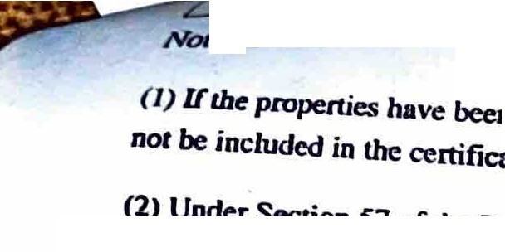

*I*

..

lilt. 0

ADDfication No : 2023039015909

ADpJicant *Name* : SURESH CHANDRA SWAIN

Form Nti Z6.

Certificate *of* E·ncumbrap·c · · Property

.,

J

, I/ I

Cert!ficate·No. : EC0392023013682

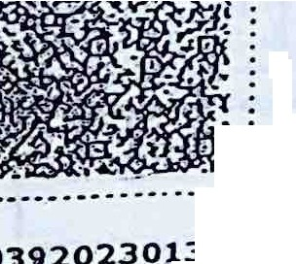

ij

I•

* ..............-....--...l.......

f*1:*

*·0wner* Namc(as per appricaoon) :

ICAKOLU VENKET SWARUL AUl),V,$41:J.RY St.!Blll:Stt NAIDU·.

Having applied to me for a certificate giving particulars or regi$t'ered 8'cl:$ a111;f ehcumbrances,if any 1., pect or underm-entioned prope,:tt. :..-

·

- • . '

. - ·- -- -

-$'1".HO. Village

7

K<hata No.

81(# - . *I*

**A11ie.**

*tfo'J1h* BQ.undory

WG. t:8·9. *:*··'

st nounda,v

South Boundary

l BEl.AGAOUA-.)4

2 BHAGACHIA-34 . *1*

7Sl/ll IS

240 *1*

,,-n--.-

*"i* I

O.iJ.

(100Ql:/l=Mo-

·

l

0.%2

(1 1Aa

-.-

---..-.-f--, 4-<-·--

•'--------

-- ----•--------

e•)

- -------1, --··-

l BEUIGACHIA-)4 .

751/193

1ssn1os

, ,j

1J

**.0.06**

Decimal

(100.00'=1Aa

et

-------t---------··---+-- -

*z* •--.J--•·- - ------· -..J. ----.-------"---+--' ,t--

1. BElAGA'"HIA-)4

7S1/5,74

178

0.21

* Decimal

(1Q000=1

•.. e)

1----+ •

-· - -

_,_

--+-r---e----

* - - - ·----·- 1---

1. Of lAf,Af"..HIA f4

,.

*:"*

655

J *17*

0.17

Oeon;al

(IOOOC>: IACI

C)

• , ,\f,4,N,4,i •.1 .J ,'I"U'°lfO"I\"

*V*

·•.

*''*t*"*,;,r"*..*·*..'.i" ,..*n*. ••*r*•*

'•

..,-:



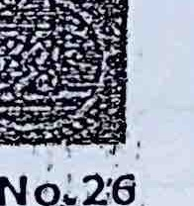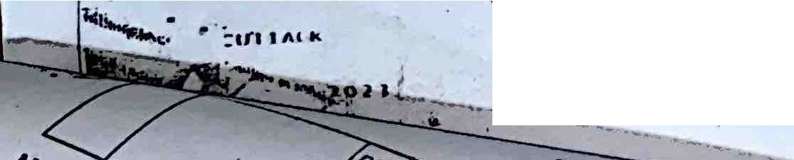

•;1,,,,,tl u,,. ••' k••,,, .,,., u,9 OHiccr